ARYAMAN MISHRA 19BCE1027

**Comparing WAN Vs. LAN Vs. MAN**

|  |  |  |
| --- | --- | --- |
| **WAN** | **LAN** | **MAN** |
| Wide Area Network | Local Area Network | Metropolitan Area Network |
| A WAN will typically cover a larger area geographically, such as a continent, a state or a country. | A LAN connects computers within a small and specific area geographically. | A MAN is confined to a specific town, city or region. It covers a larger area than a LAN but a smaller area than a WAN. |
| For data transfer, there is low bandwidth. | For data transfer, there is high bandwidth. | For data transfer, there is a moderate bandwidth. |
| It will typically have a distributed ownership model. | It is typically owned by an individual or an organization. | It can be owned publicly or privately. |
| A WAN network will have a larger coverage area that can range up to 100,000 KM and in some cases, stretches globally or over international borders. | A LAN network is limited to between 100-1000 meters coverage. | A MAN network is will usually stretch up to an area of 100 KM. |
| It costs more to set-up a WAN than a LAN or a MAN. | It has a low cost of set-up. | It has a moderate cost of set-up. |
| With a WAN, you can get lower speeds of data transfer of 10-20 Mbps. | With a LAN, you can get higher speeds of data transfer with 10/100/1000 Mbps Ethernet (high speed). | With a MAN, you can get speeds of data transfer up to 100 Mbps. |
|  |  |  |
|  |  |  |
|  |  |  |
|  |  |  |

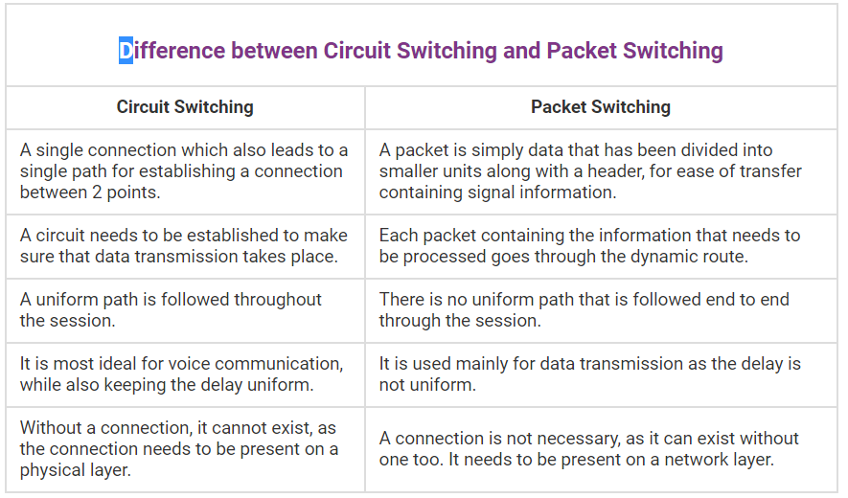

**Attenuation –** It means loss of energy. The strength of signal decreases with increasing distance which causes loss of energy in overcoming resistance of medium. This is also known as attenuated signal. Amplifiers are used to amplify the attenuated signal which gives the original signal back.

**Distortion –** It means change in the shape of signal. This is generally seen in composite signals with different frequencies. Each frequency component has its own propagation speed travelling through a medium. Every component arrive at different time which leads to delay distortion. Therefore, they have different phases at receiver end from what they had at senders end.

**Noise –** The random or unwanted signal that mixes up with the original signal is called noise. There are several types of noise such as induced noise, crosstalk noise, thermal noise and impulse noise which may corrupt the signal.

1. Any loss in the strength on the signal because of resistance of the medium is called as attenuation. On the other hand, distortion is any alteration of the original signal induced by the attenuation, noise or any other type of interference.
2. Attenuation does not change the waveform of the signal while distortion does change it.
3. Overcoming from the effects of the attenuation is easy. As against, distortion effects are harder to remove.
4. When the level of amplitude reduces over the specific amount in the signal, it is known as attenuation. On the contrary, distortion is the attenuation happening at the different amount and distinct parts of the signal.

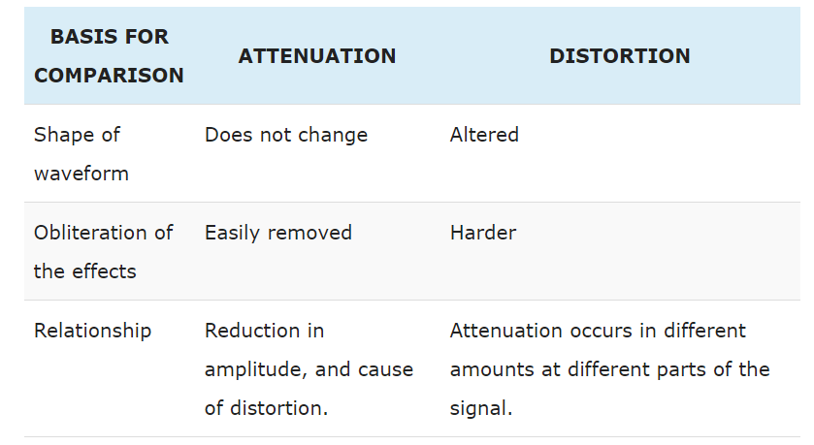

In telecommunications and computing, bit rate is the number of bits that are conveyed or processed per unit of time. The bit rate is quantified using the bits per second unit, often in conjunction with an SI prefix such as "kilo", "mega", "giga" or "tera".